Project Documentation

1. About the Project
This project studies Amazon sales data from an apparel and accessories seller. It finds out how sales change over time, which products sell, how well delivery works, who the buyers are and where orders come from. The results are presented as a written report and an interactive Power BI dashboard.

2. Technology Stack
These are the tools used in the project and what each one does.

Tool | What it does in this project
Python | The main programming language, used to clean and analyse the data
pandas | Python library that loads the CSV file and handles cleaning, filtering, grouping and totals
matplotlib | Python library that draws the charts and saves them as images
VS Code with Jupyter Notebook | The place where the code is written and run, one small block (cell) at a time
venv (virtual environment) | Keeps this project's Python libraries separate from other projects
Power BI Desktop | Builds the interactive dashboard with charts, cards and filters
DAX and Power Query | DAX writes the calculations (revenue, orders, cancellation rate). Power Query sets the data types when data is loaded
CSV files | The format of the raw data and of the cleaned data passed to Power BI
Microsoft Word | Used to write the analysis report and this documentation
Microsoft Excel | Used to open and inspect the raw CSV file and get a first look at the data before cleaning it in Python.

3. How the Project Works
The data moves through five simple steps. One cleaned file feeds both the analysis and the dashboard, so they always show the same numbers.
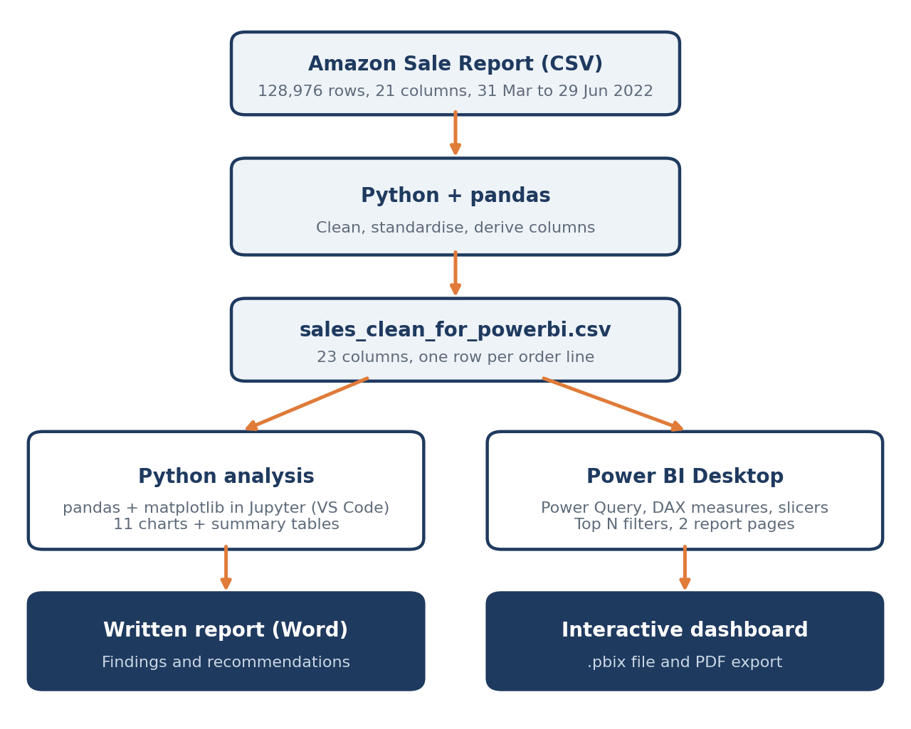
Figure 1. Project workflow
- Collect the data - The project starts with one CSV file of Amazon orders. Each row is one product on one order.
- Clean it with Python - pandas loads the file, fixes the dates and spellings, standardises state names and removes empty columns. Cancelled orders are kept apart so they do not count as sales. The result is saved as a new, cleaned CSV file.
- Analyse and chart - In a Jupyter Notebook, pandas groups the data by month, product, size, fulfilment method and state to answer the project's questions. matplotlib draws the charts and saves them as images.
- Build the dashboard - The cleaned file is loaded into Power BI Desktop. DAX measures calculate the key figures, and two report pages with filters (slicers) let anyone explore the numbers.
- Write it up - The findings, charts and recommendations are put together in a Word report.

4. Key Results
- Revenue of ₹71.7 million from 100,600 orders, with an average order of ₹712.
- T-shirts, Shirts and Blazers bring in 91% of revenue.
- Monthly sales fell each month, from ₹26.2M in April to ₹21.4M in June.
- Merchant-fulfilled orders are cancelled more often (17.5%) than Amazon-fulfilled ones (12.8%).

